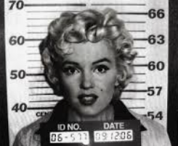 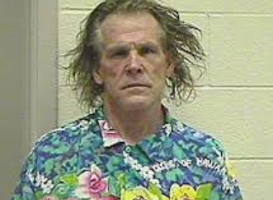

**Case Narrative**:

**Proposed Draft Charges:**

**Charge I –**

Specification 1 [XXXXXXXXXXXXX, Article XXXXXX]: In that

**Charge II –**

Specification 1 [XXXXXXXXXXXXX, Article XXXXXX]: In that

**Collection Point – Notices/Witnesses/Evidence Lists:**

|  |  |  |  |  |
| --- | --- | --- | --- | --- |
| **POTENTIAL WITNESSES** | | | | |
| ***GOVERNMENT*** | | | | |
| **Name** | **Role/Relevance** | **Associated Exhibits** | **Notes** | **Contact** |
|  |  |  |  |  |
|  |  |  |  |  |
|  | | | | |
| ***DEFENSE*** | | | | |
| **Name** | **Role/Relevance** | **Associated Exhibits** | **Notes** | **Contact** |
|  |  |  |  |  |
|  |  |  |  |  |
|  | | | | |
| ***POTENTIAL EXPERTS*** | | | | |
| **Field** | **Purpose** | | **Notes** | **Potential Expert** |
|  |  | |  |  |
|  |  | |  |  |

|  |  |  |
| --- | --- | --- |
| **EVIDENCE LIST** | | |
| **What/Where** | **Relevance** | **Foundation/Admissibility** |
|  |  |  |
|  |  |  |

|  |  |
| --- | --- |
| **NOTICES – MRE 304(d)** | |
| **Statement [w/citation]** | **Context** |
|  |  |

|  |  |  |  |
| --- | --- | --- | --- |
| **NOTICES – MRE 404(b)** | | | |
| **Crimes, Wrongs, or Other Acts.** | **MRE 404(b)(1) Purpose** | **Mechanism of Admission** | **Notes** |
|  |  |  |  |

Charge I – SEXUAL ASSAULT, Article 120, UCMJ

Specification 1 [XXXXXXXXXXXX, Article XXXXXXX]: In that …..

*Model Spec – In that __________ (personal jurisdiction data), did (at/on board—location) (subject-matter jurisdiction data, if required), on or about ________20__, …..*

**Max Punishment** – XXXXXXXXXX

**Alt/LIO**: XXXXXXX

|  |  |  |  |
| --- | --- | --- | --- |
| **ELEMENTS**  [DEFINITIONS] | **EVIDENCE** | **EVIDENTIARY ISSUES** | **PRELIMINARY TRIAL PREP TASKS** |
| Article XXXX |  |  |  |
| Jurisdictional Matters: Status/Location/Date | ETS: |  |  |
|  | | | |
| 1. That the Accused | A.  B.  C. | A.  B.  C. | 1. POC: Capt XXX -- ECD: XX XXX |
|  | | | |
| 2. The Accused … | A.  B. | A.  B. | 1. POC: Capt XXX -- ECD: XX XXX |

**Instructions/Miscellaneous:**