**Core leadership attributes**

*By Col. Ted Richard, 86th Airlift Wing staff judge advocate, 86th Airlift Wing Staff Judge Advocate / Published April 09, 2021*

**RAMSTEIN AIR BASE, Germany --**

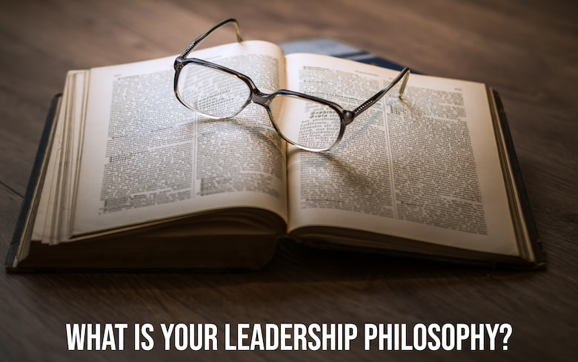 “What is your leadership philosophy?”  This was the question put to me shortly after I found out that I would be taking over as the Staff Judge Advocate for the 86th Airlift Wing.  I previously led two small legal offices, as well as teams of legal experts, but never a large group of legal professionals with a wide range of experiences and a diverse portfolio of responsibilities.  No matter the size of the team being led, an authentic, personalized approach to leadership provides the foundation to success when the job gets rough or hectic.  My leadership philosophy has five core attributes:  communication, optimism, resilience, respect, and excellence.

For me, successful leadership starts with communication because it enables collaboration, cooperation, and connectivity.  Leaders must impart their vision for accomplishing the mission and coach their teams.  For example, my leadership team’s vision for Ramstein Law Center personnel is for them to be adaptive professionals promptly employing the law to maintain discipline, ensure readiness, develop leaders, and maximize operational freedom.  Having, communicating, and reinforcing the vision helps everyone know why we do certain things and helps with prioritizing efforts.

Communication, however, is not merely direction from above.  It must also flow up the chain and across the staff so everyone on the team is informed and engaged in the mission while striving to achieve our vision.  This is true for all organizations.  Air Force Instruction 1-2, for example, directs commanders to develop a “two-way vertical and lateral communication system which is agile enough to respond to changes in the environment in a timely manner.”  Refining and improving communication is an unceasing task.  One of my earlier bosses often reminded me that we should never think we are satisfactory communicators; communication can always be improved and always needs to be tailored to the messenger, means and audience.

Communicating with optimism inspires every team to act with confidence.  Biographies of successful U.S. Presidents like Eisenhower, Reagan, Obama and others clearly describe the effusive power of optimism.  An optimistic leader sees the best in people, builds trust, and looks for opportunities to succeed.  Studies show it increases active commitment by followers.  Optimism builds esprit de corps to bond a team together.  It is a winning attitude and is infectious.  On the other hand, pessimism and cynicism are corrosive and must be actively countered.  Across all legal office operations, I emphasize optimism to overcome pessimism and to help keep our teams focused on positive solutions.

Optimism cannot be blind to reality; it must work hand-in-hand with resilience.  Great teams must have a culture of grit, perseverance, determination, and tenacity.  Just like conducting difficult military campaigns, litigating complex legal cases inevitably means encountering problems and setbacks along the way.  Rather than allowing the team to respond to mistakes with denial or self-flagellation, leaders should highlight lessons learned and keep the team oriented on moving forward.  Individual accountability, just like individual recognition, is important to reinforce the team’s reputation and to maintain trust within the team.  Resilience, however, requires the organization to concentrate on learning and advancing to complete the mission at hand.

Respect is another crucial attribute in my leadership philosophy as it guides not only our interactions within the team, but because it exemplifies how the team and I interact with clients, adversaries, and other stakeholders.  Respecting people when facing stressful situations and major disagreements is not easy.  By its nature, much of the practice of law centers around adversarial relations and zero-sum problems, but it simultaneously stresses civility as a professional responsibility.  When we respect our opponents, civility is much easier to maintain.  This works best when we try to understand the adversary’s perspectives, interests, motivations, duties, and values.  Respect doesn’t just apply to adversaries.  Respect, as a guiding principle for interpersonal relations, requires learning, understanding, and appreciating everyone’s individual interests and values.  As military lawyers, it is critically important to understand these qualities in our commanders, units, and legal assistance clients who seek our advice.  And by framing this key attribute as respect, professionalism and civility stay at the forefront.  Framing the attribute as respect also enables a straightforward, objective means to communicate trust, accountability, and recognition.

Finally, excellence is the attribute that directly informs me and my team on how to approach our vocation.  The Air Force mission demands speedy and timely legal advice.  Lawyers, by their nature, want to provide perfect products, but we cannot let the delayed perfect be the enemy of the timely good.  Therefore, I focus my team on proceeding with deliberate speed, meaning that we must work efficiently while taking the necessary steps to minimize mistakes and thereby provide accurate – and helpful – legal advice to our clients at the speed of relevance.  With the emphasis on excellence, expectations for high quality standards are clearly set.

These core attributes of communication, optimism, resilience, respect and excellence have provided me with the guiding principles to lead trial teams, small legal offices, expert legal professionals in war, and now one of the busiest legal offices in the Air Force.  While I am still growing as a leader, these attributes provide me with an authentic foundation upon which to keep building.