THE F.L.O.P. CLUB

**SpeedLead Event**

On a monthly basis, Third Air Force offers its CGOs professional development opportunities through our F.L.O.P. Club construct [Followership-Leadership-Officership-Professionalism]. For the most recent session, we created SpeedLead, a speed-dating inspired event that was chaotic fun and provided our CGOs multiple (quick) opportunities to interact with a range of senior JAGC leaders. Essentially we set senior leaders (O-6/O-7 JAGs) in individual Zoom breakout rooms and the CGOs went from room to room every five minutes asking leadership questions. It is easily reproducible, though the logistics can be a challenge, so a walkthrough follows if you are interested in setting up a session for your CGOs.

- Get a head count of the number of CGOs and senior leaders who will participate. We set the session for 1500CET (Germany) so with the 6-hour time difference we could still include East Coast US (mostly NCR) O-6/O-7s. We ended up with 14 senior leaders and 29 CGOs. [Atch 1 is the Info Flyer and Atch 2 is the Team invite; Col BT subbed in for Gen Vernon at the last minute because of an unexpected conflict, definitely a poor alternative].

- Easy to flex if someone drops out at the last moment. You can triple up the CGOs, or move them to singles and doubles, and if a senior leader has to drop, you can just leave their breakout room empty and the CGOs can use it as a “Green Room” to catch their breath before the next switch.

- Get the CGOs thinking of the questions they are going to ask during the session. We put together Atch 3 to help get them get started … in the end, about half of the CGOs accepted the challenge and came up with their own questions … but putting this together, and sending it to the senior leaders in advance so they could think through what their answers might be, was a useful exercise in and of itself.

- Plan a technology run-thru about a week before to allow attendees (particularly the CGOs who will jump from breakout room to breakout room) to be comfortable with all the Zoom features they will need to know. [We did not do this, assumed the CGOs were tech-savvy, not so much].

- Put together a summary of the bios of the senior leaders, and a list of the CGO attendees and their bases, and get that out a week before (so the CGOs can realize the firepower coming to mentor them). Atch 4 is our version and we also downloaded their official bios and combined them into one PDF file … some of the standout CGOs had reviewed the bios and tailored their questions accordingly, nice touch.

- If you can do one-on-one (same number of senior leaders as CGOs), that is great, but once you get above 10-15 of either the math becomes harder. You want to work it so that the CGOs switch rooms about every five minutes, and you can run it as long as you like, but 90 minutes is probably the maximum. With a ~5-10 minute intro (to review the rules, thank everyone for attending, and handling late arrival and tech issues when you first send folks to their rooms) and a couple minutes to close it out, you probably should work the math to complete all the switches within 80 minutes. We had an overwhelming positive response from the senior leaders (14) and CGOs (29), so doubling up the CGOs made the most sense. Frankly, once the thing starts it’s hard to keep everyone going in the right direction at the right time, but as long as you set it up right and have a plan after the initial chaos and once everyone gets used to the plan of movement it runs more “smoothly.”

- Our plan was five minutes in each room and then switch to a new room. In Zoom, the host (and co-hosts) can send a message that appears on all the breakout room screens. We sent one at 4 minutes 30 seconds that said “Switch in 30, 29, 28 …” and then another that said “Switch” at the 5-minute mark. It took a while for folks to pay attention to the messages (some folks talked longer than others, not unexpected, so expect a bit of chaos). Teamed up, once everyone figured out how to switch themselves (see earlier note about a trial run a few days before), we found that five minutes per room gave each CGO a chance to ask one question. If we had more time, or fewer participants, we would have gone with a five-minute-per-room period with a one-minute switch period between each.

- In Zoom, a host or co-host can manually move people from room to room. We did this to put people in rooms (mostly the senior leaders) at the start or when folks were having trouble with the technology. We did not mind the chaos of letting people move themselves around (gives it more of that speed-dating feel), but if you are uncomfortable with that, you could devise a schedule, assign x number of co-hosts the responsibility of moving x number of CGOs at every switch, and they could manually pluck them out of one room and into another (problem with that is you likely cut off a conversation in mid-sentence). I say embrace the chaos.

- However you do it, have a Breakout Room guide that lists who is in what Breakout Room, and where each CGO or CGO team starts. Atch 4 (Logistics) was ours. You can and should name the Breakout Rooms the same way (*e.g.,* 1 Col Smith, 2 Col Green, etc.). We found having the Logistics lineup helped us put people in the right place when inevitable tech issues arose.

- Technology-wise the best way for people to join is through a Zoom app on their personal computers or phones. [We have a Zoomgov account, but it has fewer features than the personal Zoom account which we used]. The next option, which most used, was through their browser (we found Chrome to be the best browser for this). A word of warning, there was a tech glitch a couple of our folks had that when they tried to move from breakout room to breakout room they would be kicked out of Zoom completely and would have to log back and land in the Main Room, and then would go to or be placed in their next Breakout room. Unclear whether this was a computer or browser (or user) error; it was inconvenient, but did not prevent those couple folks from participating (again, a dry run a couple days earlier would have been a smart move on our part).

- GAME DAY: Open the room early, say an hour ahead of time. As people log in, offer them an audio/video check. We had no problem with everyone having their video on. Solicit a couple FGOs (DSJAs) to serve as “moderators” to sit in the Breakout Rooms to help the senior leaders with any tech issues (and really keep everyone on track and moving…we only had a couple and really should have had one in each Breakout Room). Expect a bit of chaos and folks to miss the room switch notice, and some rooms to back up and some rooms to be empty. About half way through we extended one of the five-minute periods to 10 minutes to allow everyone to get back on track—probably was not necessary as people figured out the flow after a few switches, but giving a few extra minutes to allow folks (like our host/co-hosts) a few minutes to catch their breaths was worth it.

- We had a soft script to start and end the session. We have included part of it as Atch 5.

- The overall goal of this is to get the CGOs thinking about their own leadership philosophies (a focus area for The F.L.O.P. Club). So Session 2 is the same but different – same in logistics in that the senior leaders stay in their Breakout Rooms and the CGOs go from room-to-room, but different in that this time the senior leader will be asking the CGOs leadership questions. Yes, the CGOs will regurgitate probably a lot of what they heard the senior leaders talking about in Session 1, but at least they are thinking about all the different philosophies and what may or may not work for them. Frankly, a lot of this is forcing the CGOs to think about these topics with the side benefit of allowing them to interact with O-6/O-7s, which you may recall is not something you likely had much of an opportunity to do during your early CGO days. We provided them some materials to help them think through their philosophies, Atch 6.

- If you are interested in setting up something like this within your NAF, for a small fee (really just candy) MSgt Adam McConnaughy and I are happy to work with your POC to make it happen or even run it for you … The Helpful NAF™.

**Atch 1 (Flyer Info)**



**Atch 2 (Teams invite)**

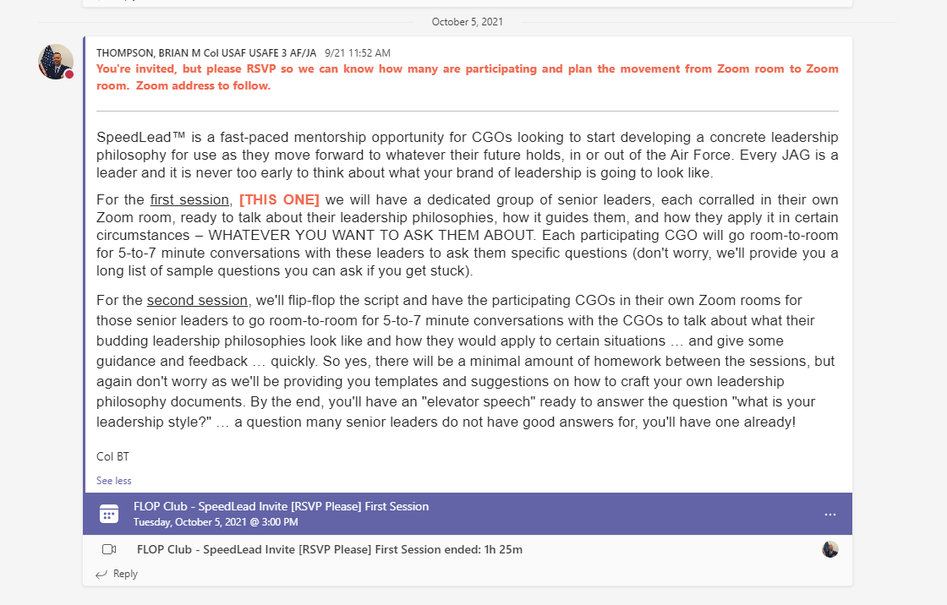

**Atch 3 [Sample Questions]**

**Sample Questions for Discussion with Senior Leaders\***

* What does leadership mean to you?
* What do you think the top couple keys are to being a successful leader?
* How would you describe your leadership philosophy? [Elevator speech or shorthand phrase]
* What is one of your greatest strengths and how does it influence your leadership philosophy?
* What is one of your greatest weaknesses and how does it influence your leadership philosophy?
* What is your natural leadership style and why? How does this impact your leadership philosophy?
* As a leader, how if at all would you adjust your leadership style to ensure they you are reaching everyone, understanding that the military brings together a diverse group of backgrounds and experiences?
* What is a leadership style or technique that you find challenging to employ? How did you overcome this challenge? How does this impact your leadership philosophy?
* What was your process to develop your leadership philosophy?
* How has your leadership philosophy evolved over time? How can you tell when it’s time to try a different approach [how do you judge success or failure].

**\*Feel free to use any of these, but feel even more free to ask questions that you think will better help you build your own leadership philosophy. These are definitely NOT the required questions/script.**

**Atch 4 [Attendee Bios and Logistics]**

**Senior Leader All-Star Line Up**

[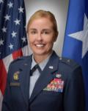](https://roster.jag.af.mil/pls/rosterdad/ROSTER.showPhoto?person_key=15228)

Brigadier General Rebecca Vernon is the Director of the Military Justice and Discipline Domain. She entered the Air Force in 1996, is a graduate of National War College, and has served as an SJA at the Wing, Deployed, and MAJCOM level.

[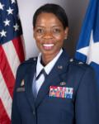](https://roster.jag.af.mil/pls/rosterdad/ROSTER.showPhoto?person_key=12623)Brigadier General Gail Crawford is the Director of the Operations and International Law Domain. She entered the Air Force in 1997, is a graduate of Air War College and the LL.M. program, and has served as an SJA at the Wing, Deployed, Center, and MAJCOM level.

[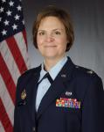](https://roster.jag.af.mil/pls/rosterdad/ROSTER.showPhoto?person_key=14587)Colonel Natalie Richardson is an AFCCA judge. She entered the Air Force in 1995, is a graduate of ACSC, served as a Wing and Deployed SJA, was the AFLOA Vice CC and then Commander, and has been on the bench for numerous assignments.

[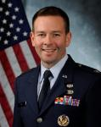](https://roster.jag.af.mil/pls/rosterdad/ROSTER.showPhoto?person_key=13647)Colonel Jamie Key is an AFCCA judge. He entered the Air Force in 1993 after graduating from the Air Force Academy and joined the JAGC in 1998. He is a graduate of the LL.M. program and has served as the Chief of both the Environmental Law and Litigation Division and the Special Victims’ Counsel Division.

[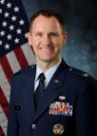](https://roster.jag.af.mil/pls/rosterdad/ROSTER.showPhoto?person_key=13831)

Colonel Michael Lewis is a Senior AFCCA judge. He entered the Air Force in 1995, has served as an SJA at the Wing, Deployed, and NAF level, and was the Chief of the Military Justice Division.

[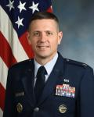](https://roster.jag.af.mil/pls/rosterdad/ROSTER.showPhoto?person_key=14326)Colonel Jeff Palomino is the Chief of the Trial Defense Division (and former Chief of the Appellate Defense Division). He entered the Air Force in 1999, is a graduate of ACSC and the LL.M. program, served as a Wing SJA, and White House NSC Legal Advisor.

[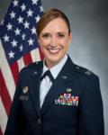](https://roster.jag.af.mil/pls/rosterdad/ROSTER.showPhoto?person_key=17757)Colonel Cynthia Kearley is the Director of Legal Services USAFE-UK Host Nation Coordination Cell. She entered the Air Force in 2000, is a graduate of Air War College, served as a Wing and Deployed SJA, and was recently the AFJAGS Deputy Commandant [and of course our The F.L.O.P. Club co-founder].

[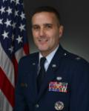](https://roster.jag.af.mil/pls/rosterdad/ROSTER.showPhoto?person_key=20602)Colonel Paul Condie is the AFDW SJA. He entered the Army in 2001 before seeing the light and transferring to the Air Force JAGC in 2007, and has served as an SJA at the Brigade and Wing three times before his current NAF-level SJA assignment.

[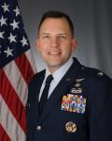](https://roster.jag.af.mil/pls/rosterdad/ROSTER.showPhoto?person_key=16973)Colonel Ted Richard is the Ramstein (86 AW) SJA. He entered the Air Force in 2001 after 10 years in the Wisconsin Army National Guard, and before that worked as a private detective! He is a graduate of the LL.M. program, and has previously served as a Wing SJA and C/AOC Legal Advisor.

[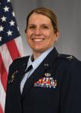](https://roster.jag.af.mil/pls/rosterdad/ROSTER.showPhoto?person_key=18879)

Colonel Chelsea Bartoe is the Deputy Director of the Military Justice and Discipline Domain. She entered the Air Force in 2003, is a graduate of ACSC, and has served as an SJA at the Wing (Alconbury!) and Deployed level, as well as a NAF Deputy.

[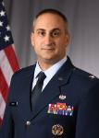](https://roster.jag.af.mil/pls/rosterdad/ROSTER.showPhoto?person_key=17629)

Colonel Michael Burnat is the Chief of the Appellate Defense Division. He entered the Air Force in 2002 and served as the DSJA RAF Lakenheath and the SJA at RAF Mildenhall … a Third Air Force alum!

[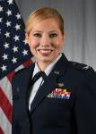](https://roster.jag.af.mil/pls/rosterdad/ROSTER.showPhoto?person_key=17888)Colonel Tiffany Wagner is the Director of the AF Review Boards Agency’s Legal Support Directorate. She entered the Air Force in 2002, is a graduate of the LL.M. program and National War College, and served as a Wing SJA and two assignments as a military judge.

[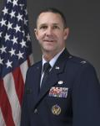](https://roster.jag.af.mil/pls/rosterdad/ROSTER.showPhoto?person_key=18035)

Colonel Damon Scott is the Chief of the Environmental Law and Litigation Division. He entered the Air Force in 2002, is a graduate of the LL.M. program, and in addition to numerous deployment has served as an SJA at Mountain Home AFB.

[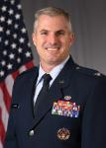](https://roster.jag.af.mil/pls/rosterdad/ROSTER.showPhoto?person_key=17880)Colonel Kevin Catron is the 316 Wing SJA, the JAGC Legal Office of the Year 2020. He entered the Air Force in 2002, is a graduate of ACSC, and has served as an SJA at the Wing three times (including in Norway), and is an Honorary Member of 3AF!

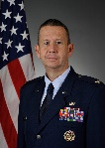Colonel Brian “BT” Thompson is the Third Air Force SJA … and of course **King FLOP**. He entered the Air Force in 2001, completed the Legislative Fellowship Program, and has served as a Wing, Deployed, and now NAF SJA, and was the AF’s Chief Senior Trial Counsel [which he never fails to mention].

**The FLOP’ers**

Capt Vincent Bennett (31 FW--Aviano)

Capt Sarah Swyers (31 FW--Aviano)

Capt Logan Myrick (31 FW--Aviano)

Lt Kiarra Brown (31 FW--Aviano)

Capt Marcus Williams (316 WG--Andrews)

Lt Katarina “Kat” Marczeski (316 WG--Andrews)

Capt Sarah Needham (316 WG--Andrews)

Capt Diandra Romero (48 FW--RAF Lakenheath)

Capt Christine Austin (48 FW--RAF Lakenheath)

Capt Chase Haggard (48 FW--RAF Lakenheath)

Capt Bryan Bowyer (48 FW--RAF Lakenheath)

Lt Sarah Barrett (48 FW--RAF Lakenheath)

Capt Ashleigh Berglund (100 ARW--RAF Mildenhall)

Capt Eric Trudrung (100 ARW--RAF Mildenhall)

Capt Joseph Klein (100 ARW--RAF Mildenhall)

Capt Tyler Gass (52 FW--Spangdahlem)

Capt Christian Horde (52 FW--Spangdahlem)

Capt Therese O’Brien (39 ABW--Incirlik)

Capt Steven Shilling (39 ABW--Incirlik)

Capt Jennifer Schuelke (39 ABW--Incirlik)

Capt Taracina Bintliff (JAJS, Ramstein AB)

Capt William Thompson (86 AW--Ramstein)

Capt Stephen Tomasek (86 AW--Ramstein)

Capt Doug Bryson (86 AW--Ramstein)

Capt Rachael Swiatek (86 AW--Ramstein)

Lt Ashley Hartshorn (86 AW--Ramstein)

Capt Raquel Muscioni (86 AW--Ramstein)

**LOGISTICS**

BREAKOUT ROOM TEAM START

1. Col BT Capt Swyers/Capt Gass #1

2. Col Kearley Capt Bennett/Capt O’Brien #2

3. Col Condie Capt Myrick/Lt Hartshorn #3

4. Col Richardson Lt Brown/Capt Williams #4

5. Col Wagner Lt Marczeski/Capt Klein #5

6. Col Key Capt Needham/Capt Haggard #6

7. Col Richard Capt Romero/Capt Horde #7

8. Brig Gen Crawford Capt Muscioni/Lt McHenry #8

9. Col Catron Capt Austin/Capt Thompson #9

10. Col Lewis Capt Bowyer/Capt Bintliff #10

11. Col Scott Lt Barrett/Capt Shilling #11

12. Col Bartoe Capt Berglund/Capt Clark #12

13. Col Burnat Capt Trudrung/Capt Swiatek #13

14. Col Palomino Capt Schuelke/Capt Bryson #14

**ZOOM & MOVEMENT PLAN**

Please join us in the Main Room at 0900/1500, we’ll zip through a short introduction and then send everyone to their Breakout Rooms above. At 0910/1510 we’ll start the clock and we’re off to the races. The plan is to rotate every five minutes…we’ll give a warning with 30 seconds left and then a direction to move. CGOs move to the next room (*e.g.,* #1-->#2, #2-->3 … #14 -->#1). If you hit an empty room, just hang out for the five minutes and switch at the next 5-minute mark. At the end, all please return to the Main Room for a short sendoff. If this works right, we should be done within 90 minutes.

Join Zoom Meeting  
<https://us02web.zoom.us/j/83474780766?pwd=b2xpYThVQVU4ZVlEeWIrbi9xeURjQT09>  
  
Meeting ID: 834 7478 0766  
Passcode: leadership

[Note the name of the Zoom site is Club2442; that’s us, it’s not a trendy nightclub]

**Atch 5 (Soft Script)**

BT: Really excited about today, and I know I say that about every FLOP Club event, but today I really mean it. I’m pretty sure we have the greatest collection of senior JAGC leaders and CGO ever assembled to talk about leadership … as in ever in the history of the United States Air Force.

AM: Wow, is that true?

BT: I don’t know if that’s true but it sounds true so we’ll say it is. Our senior leaders collectively have more than 300 years of JAG time, and have served as SJAs and equivalents about 50 times. Wow. And our CGOs from 3AF and our honorary Wing there at Andrews, of course, hands down represent the best of the JAGC’s future. So thanks to everyone participating today, we really appreciate you taking the time from your busy schedules to help develop the next generation of JAGC leaders.

BT: I know I’ve emailed the instructions until you’re sick of hearing them, but one more time. Each senior leader is assigned a breakout room and you get to stay there. To get to the breakout rooms, you should see a little, three-dot icon there at the bottom of the screen and if you click on it one of the options is hopefully breakout rooms, just pick the one assigned to you and off you go and if there is a problem we can just send you there manually. The CGOs are teamed and will start in a particular breakout room and then switch every 5 minutes. We’ll send a text that will appear at the top of everyone’s screen with 30 seconds left and then another at the 5-minute mark for the CGOs to move to the next room down the list, so from 1 to 2, 2 to 3, and 14 to 1 and so on until we’re done. If you hit an empty room, just hang out and move when directed at the next 5 minute mark. When we dry-ran this 5 minutes seemed to be the sweet spot, couple questions, time to discuss but not a ton … it will move fast so be ready with your questions.

BT: And remember FLOP’ers the goal is to hear lots of different perspectives on leadership today so over the next month you can think about what yours may look like, before we turn the tables. And it’s probably nice for you all to talk to colonels and generals who don’t have the initials BT **[APPLAUSE]**

BT: Ok, it’s now ____ please head out to your breakout rooms and be ready to move at the first switch at 0915 or 1515 or 1615 or 1415 … lots of time zones today. I expect chaos. Couple extra minutes in the first one. MSgt McConnaughy will stand by here in the Main Room in case there are any issues and I’m going to swap in for Gen Vernon, poor substitute I know, sorry about that. Off you go. See you back here in the Main Room when we’re done.

BT: All welcome back. I won’t put anyone on the spot so I’ll just assume that was the greatest leadership/mentorship event in the history of the Air Force. Really appreciate everyone participating in our little experiment, seemed to work. Special thanks to all our senior leaders … [name] … **[APPLAUSE]** We’re next up on the schedule Tuesday 16 Nov for Session 2 of SpeedLead. I’ll send out some details and helpful templates by the end of the week.

**Atch 6 [Session 2 Prep Material – Developing a Leadership Philosophy Exercises]**

